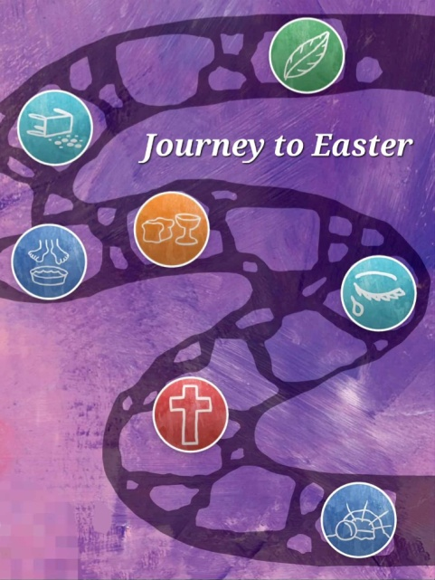
St. Mary’s Pastoral Charge
189 Hwy 347 Aspen NS B0H 1E0

Dear Friends,

The journey to Easter begins at Christmas with the birth of the Saviour of the World. Jesus grew up and began his public ministry at age thirty, being baptized. After spending a period of forty days fasting and praying in the wilderness, He spent the next three years travelling around preaching and teaching, challenging and comforting, healing and performing miracles. He gains a large following, but those in authority, both government and religious, are not happy. An order seeking his arrest is issued, charged with blasphemy and with inciting rebellion.

The last week of the journey includes the final days of Jesus’ earthly life, His death, burial, and on Easter Sunday, His resurrection. This is an important time for Christians to reflect deeply on the core tenants of our faith and on God’s infinite love and mercy. It is meant to be a time of reflection, prayer, repentance and renewal.

I invite us to journey to Easter together, by doing the daily readings for Holy Week (March 24-31) that are provided on the enclosed map, and by sharing in all of our services of worship, designed to make the journey more meaningful, open our hearts, draw us nearer to Christ and strengthen us for faithful living.

My family and I wish you all a very blessed Easter!

In Christ’s Service,


Derek G. Elsworth
Minister

“Jesus said, ‘If anyone serves me, he must follow me; and where I am, there will my servant be also.
If anyone serves me, the Father will honor him.’” ~ John 12:26

Telephone: 902-833-2920 * Email: stmaryspastoralcharge@ns.aliantzinc.ca * Website: stmaryspastoralcharge.com
Holy Week Services – Join Us On The Journey!

Palm Sunday... March 24, 9:30am Bethany/Zion at Bethany in East River St. Mary's, 11:00am at St. John’s in Sherbrooke, 6:30pm at Kirk in Glenelg.

Maundy Thursday & Holy Communion … March 28, 6:30pm at Bethany in East River - St. Mary's.

Good Friday… March 29, 6:30pm at St. John’s in Sherbrooke.

Easter Sunday... March 31, 9:30am Bethany/Zion at Zion in East River St. Mary's, 11:00am at St. John’s in Sherbrooke, 6:30pm at Kirk in Glenelg.

