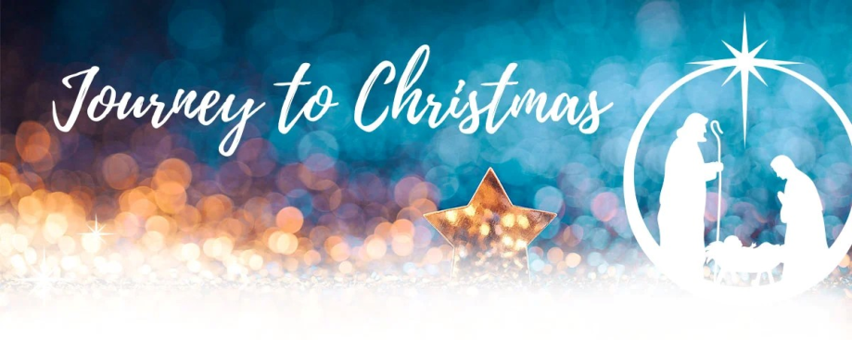
St. Mary’s Pastoral Charge
189 Hwy 347 Aspen NS B0H 1E0

Dear Friends,

Within the biblical Christmas narrative we hear a lot of references to journeys. The angels journey from heaven to earth to proclaim glad tidings. Mary journeys to visit her cousin Elizabeth. Mary and Joseph journey to Bethlehem for a census. The shepherds journey from the fields to a stable, where they find Mary, Joseph and a new born baby, who is wrapped in bands of cloth and lying in a manger, just as the angels told them. The Magi journey from the East, following a star, bringing gifts of gold, frankincense and myrrh to honor this child, Jesus, God with us. And finally, Mary, Joseph and Jesus journey to Egypt, to escape from evil King Herod.

The season of Advent, the four weeks leading up to Christmas, is meant to be a journey too. It is a journey of spiritual preparation for Christians, encouraging us to open our hearts to the One whose birth we celebrate.

On each of the four Sundays of Advent, our journey to Christmas will look at who Jesus is from the perspective of a different gospel writer. Matthew, Mark, Luke and John together give us a fuller understanding of Christ and who we are called to be in Him.

For me, I am grateful to be on this ministry journey with you all. Amanda, Josh, Zach and Julia join me in extending God’s blessings for a very Merry Christmas and a Happy New Year!

In Christ’s Service,
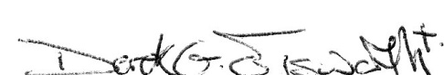
Derek G. Elsworth
Minister

Telephone: 902-833-2920 * Email: stmaryspastoralcharge@ns.aliantzinc.ca * Website: stmaryspastoralcharge.com
Join Us On The Journey!

Sunday Worship December 3, 10, 17... 9:30am at Kirk in Glenelg, 11:00am Bethany/Zion at Bethany in East River St. Mary's, and 6:30pm at St. John's in Sherbrooke.

Community Choir Christmas Concert... Saturday, December 9, 7pm at St. John’s United Church, Sherbrooke. Freewill offering to provide winter coats/boots for children in need at St. Mary’s Education Centre Academy.

Christmas Open House at the Manse... Friday, December 15, 7:00pm.

Evening of Christmas Music… Saturday, December 16, 7:00pm at Zion Presbyterian Church, East River St. Mary’s. As has become our tradition, the evening will be filled with carols, several special musical guests and The Bells of St Mary's. Again, we invite all former CGIT members to attend and help end our evening with candlelight and the singing of “Let There Be Peace on Earth.” Cider and cookies will be served at the end of the evening.
Service of Light and Holy Communion... Wednesday, December 20, 6:30pm at Bethany in East River St. Mary’s.

Christmas Eve Service... Sunday, December 24, 6:30pm at Kirk in Glenelg.

Sunday, December 31... No Services (including online), please worship with another congregation!

Sunday Worship in January... 9:30am at St. John's in Sherbrooke, 11:00am at Kirk in Glenelg and 6:30pm Bethany/Zion at Bethany in East River St. Mary's.

Financial Giving... Our gifts are an act of worship and thanksgiving for God’s blessings. Thank you for your faithfulness and spirit of generosity. Please continue to prayerfully consider you’re giving’s to Christ and His church. God bless you! Ask about PAR, Pre Authorized Remittance! This would be greatly appreciated! An envelope has been attached to this letter for a special Christmas Offering. This additional gift along with your regular giving will help to sustain the church’s vital ministry in our community!

Thank You... to everyone who contributes to the life of our pastoral charge in any way. We have so many wonderful volunteers, and people give generously of their time, talent and treasure. You are appreciated – God bless you!

For more information... watch the bulletin, visit us on facebook or at our website for news about other events in the life and work of our church. Feel free to contact us for more information or to inquire about Sunday School (JAM Club), Youth Group, women’s groups, men’s groups or Bible Study. Online worship continues to be offered.

